* In this we have used a-frame-ar-nft.js library.
* <a-nft> tag,<video>,<a-video> tags.
* ngrok to run the application.

Set up the meta information in the <head> tag 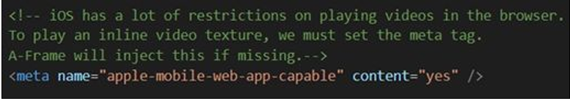

2) Add <div> in the <body> to show the loading descriptor till the time video content is loaded.

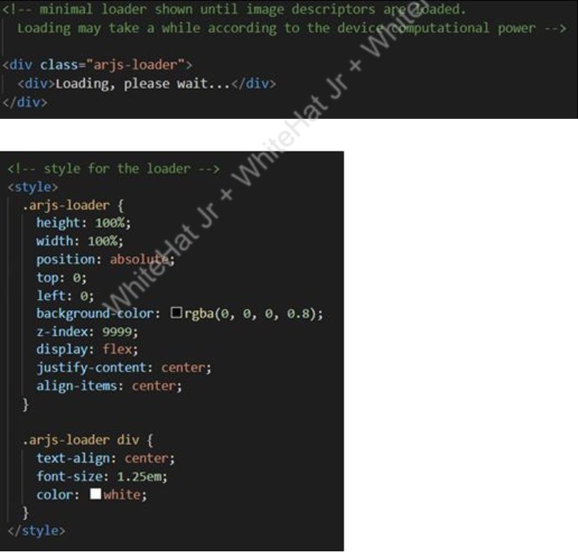

3. Set the <a-scene> element component:   vr-mode-ui=”enabled: false;” ● renderer=”logarithmicDepthBuffer: true;” ● embedded  ● arjs=”tackingMethod: best; sourceType: webcam; debugUIEnable: false;”

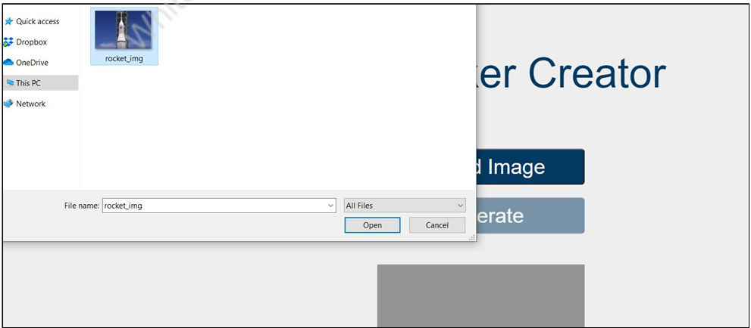

4. Takeanimageandopenitfromthesystem,uploadintheNFTtothecreator,and click on “Generate”.

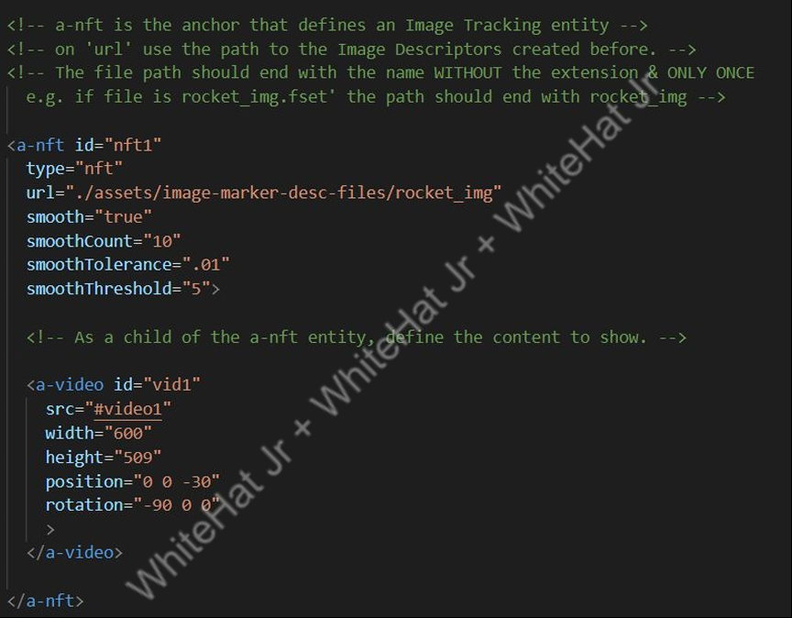

5 To set the video entity, we will use <a-video> as the child of the <a-nft> and set the src id, height, width, position and rotation to set its orientation.

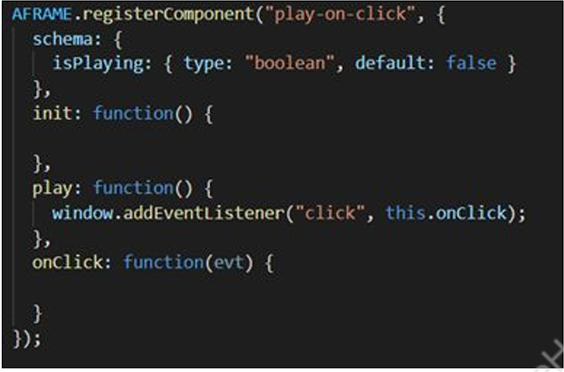

6 Write onClick() function in the component and take the videoEl variable and select the video src to be played on click in .init() method.

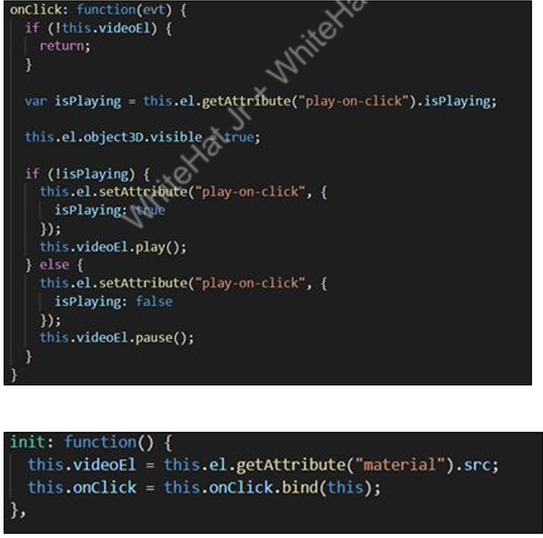

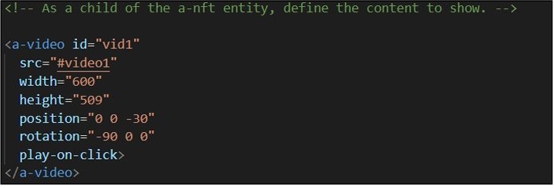

7 To see the output: ● Use ngrok to run the application. ● Open HTTPS URL in your smartphone/laptop & give permission to use the camera. ● Open the original image that was used to create the nft image marker and point the camera towards it.